**BIRLA INSTITUTE OF TECHNOLOGY AND SCIENCE, PILANI**

Batch No. :

**DEPARTMENT OF COMPUTER SCIENCE AND INFORMATION SYSTEMS**

**Artificial Intelligence (BITS F444/ CS F407)**

**I Semester 2017-18**

**Programming Assignment-1**

**Coding Details**

**(September 14, 2017)**

*Instruction: Type the details precisely and neatly*

1. ID 2015A7PS0111P

Name T Naga Datta Madhu Kiran

1. Mention the names of Submitted files :
   1. Gen.py
   2. gui.py
   3. heuristic.py
   4. main.py
   5. uninformed_search.py
   6. vaccum_cleaner.gif
2. Total number of submitted files: 6
3. Name of the folder :2015A7PSO111P
4. Have you checked that all the files you are submitting have your name in the top? -yes
5. Have you checked that all the files you are submitting are in the folder as specified in 4 (and no subfolder exists)?-yes
6. Problem formulation
   1. State representation:

State contain list of tiles condition whether it is dirty or not ? as binary.

* 1. How is the Initial state generated?

For a given percent of dirt, those many dirt positions are created randomly by using inbuilt python random library

* 1. What is the goal state?

Goal state is taken as state in which every tile is clean (i.e. two dimensional array of zeroes in code.)

* 1. Are there more than one goal states?

Yes

* 1. If yes, then describe all the goal states

one as explained in 7.c, and for calculating best first temp_goalstate is taken as whether current position dirty or not.

* 1. State representation in Python (name the construct and give one small example of a state)

It contains [current x, current y ,operation from which it is generated] as list

1. Successor function description

Function produces children based on the operation of its parent and current position.

1. Uninformed Search Technique (T1) details
   1. Technique used for search:

Iterative deepening search

* 1. Reason for selecting this technique over the other two:

Because of its space complexity over the Breadth first search and because of time complexity over the depth first search

* 1. Is the search applied on tiles or on states? - states.
  2. Error handling and reporting (yes/No): NO
  3. List the errors handled:
  4. Data Structure description for the tree node (in maximum two lines):

‘Node’ is the class used for creating node for build search tree in IDFS.

It contains

1, parent

2,tiles list (current state)

3,current position

4,what action is generated on it’s parent so that it is generated.

5,It’s Children

* 1. Code status (implemented fully/ partially/ not done)

1. Informed search Technique (T2) details:
   1. Technique used for search:
   2. Reason for selecting this technique over others:
   3. Does this technique look at a tile?
   4. Does this technique use a state?
   5. Code status (implemented fully/ partially/ not done)
   6. Define the heuristics (in words) used in your program
      1. h1 :
      2. h2 :
   7. Compute the heuristic values for the following windows with dirt in the neighborhood of the centre position of the vacuum cleaner.
      1. h1 = , h2 =
      2. h1 = , h2 =
      3. h1 = , h2 =
      4. h1 = , h2 =

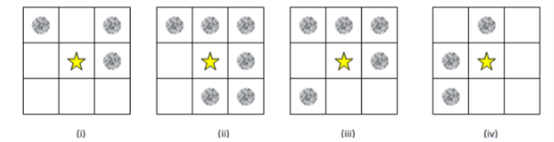

1. GUI details
   1. Created the GUI : Yes
   2. Have created it according to the specifications?:Yes
   3. Which module of Python used for creating graphics? Turtle
   4. Is this under the standard Python library or not? Yes it is standard module.
   5. If not, why?
   6. Are the window panes working independently? Yes
2. Graphics details:
   1. Is turtle graphics working fine for movement of the intelligent vacuum cleaner?-Yes
   2. How are you creating the room tiles?-Using turtle, drawing grid.
   3. How are you showing the dirt?-By making tile black
   4. How are you showing the resting position of the vacuum cleaner?

vacuum cleaner starts at resting place at beginning of execution and stops at resting position after finishing execution

* 1. Are you showing the movement of the vacuum cleaner (turtle cursor) as the execution of T1 goes on? Why? Yes
  2. Are you showing the movement of the vacuum cleaner (turtle cursor) as the execution of T2 goes on? Why? Yes

1. Compilation Details:
   1. Code Compiles (Yes/ No):Yes
   2. Mention the .py files that do not compile: no
   3. Any specific function that does not compile: no
   4. Ensured the compatibility of your code with the specified Python version: yes
   5. Instructions for compilation of your files mentioning the multifile compilation process used by you (We may use the replica of these for compiling your files while evaluating your code)”python main.py”
2. Driver Details: Does it take care of the options specified earlier(yes/no):yes
3. Execution status (describe in maximum 2 lines)

Heuristic 1&2 works fine for every percent of dirty varying(0-100)for every grid size.

uninformed Idfs works for low percent of dirt .Execution time increases as grid size increases.

1. Output Details

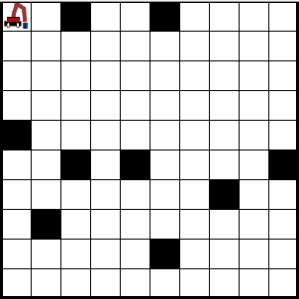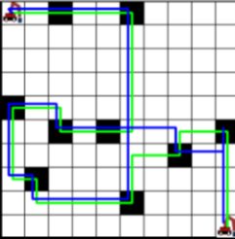 Write some more details here for the above graphs, if needed

* 1. Write the following values computed by you (refer the details of R1-R11 in the assignment document). Use appropriate units for the values

R1: R2: R3: R4:

R5: R6: R7: R8:

R9: R10: R11:

1. Declaration: I,T NAGA DATTA MADHU KIRAN declare that I have put my genuine efforts in creating the python code for the given programming assignment and have submitted only the code developed by me. I have not copied any piece of code from any source. If the code is found plagiarized in any form or degree, I understand that a disciplinary action as per the institute rules will be taken against me and I will accept the penalty as decided by the department of Computer Science and Information Systems, BITS, Pilani.

ID2015A7PS0111P Name: T NAGA DATTA MADHU KIRAN

Date:14-Sep-17

******************************************************************************* Should not exceed three pages